**Medical Deepfake Prediction Using Deep Learning**

**ABSTRACT**

Deep learning is a subset of machine learning, which is essentially a neural network with three or more layers. These neural networks attempt to simulate the behavior of the human brain, allowing it to learn from large amounts of data. Deepfake Detection is the task of detecting fake videos or images that have been generated using deep learning techniques. The goal is to identify such manipulations and distinguish them from real videos or images. The top cause of death in the world is cancer. AI has been able to accurately classify lung cancer subtypes through analysis of digital pathological tissue sections.

**Method with System Diagram/Design Complexity**

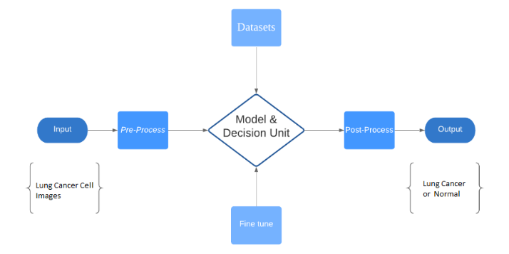In Fig. 1, an image of a cancerous cell is used as input in a block diagram. The dataset is divided into cancer and healthy patients, and pre-processing steps include loading photos of a certain size, dataset splitting, and data augmentation. The model is adjusted and fitted for higher precision. Plots of confusion matrix, model loss, and accuracy illustrate their changes over time. When a lung cancer patient's image is provided, the system determines its presence in the output. A block diagram provides the most understandable representation of the system. The decision-making part is crucial, driven by a model trained on a substantial amount of data from lung cancer cells.

**Figure 1:** Block diagram of the system.

**Novelty of Project**

This project employs deep learning to detect false lung cancer images, addressing deepfake prediction in medical imaging. It aims to enhance accuracy, reduce unnecessary procedures, and revolutionize early detection. Ethical considerations, collaboration, and regulatory adherence ensure responsible development of the system, improving lung cancer diagnostics.

**Impact on Society/Environment**

Deep learning algorithms improve accuracy in detecting false lung cancer images, enabling quick and precise analysis of medical imaging data. This reduces false diagnoses, aiding early identification of lung cancer and avoiding unnecessary invasive treatments. By reducing false positives, Deepfake prediction helps lower costs and improve patient outcomes.

**Business Model/Feasibility/Financial Scalability plan**

The main objective of utilizing deep learning techniques for lung cancer deepfake prediction is to improve lung cancer prevention, early detection, diagnosis, and care. By leveraging advanced algorithms, the system aims to identify false lung cancer images, reducing false diagnoses and enabling timely and accurate treatment. The target market segments include radiology facilities and healthcare providers. The pricing plan can be a combination of upfront software licensing fees and recurring subscription charges. The marketing and sales strategy will involve professional collaborations, online platforms, and medical conferences, showcasing educational content that emphasizes the system's advantages and success stories.

**Conclusion**

In conclusion, this deep learning project for false lung cancer image detection brings significant advancements to medical imaging. With improved accuracy and early detection, it enhances patient outcomes, reduces costs, and builds trust. Responsible implementation and collaboration make it a promising innovation in lung cancer detection. Future work involves refining models, expanding datasets, and conducting clinical trials.